**EXPERIMENT -3**

**EXP NO 3:** CREATE A SIMPLE CLOUD SOFTWARE APPLICATION FOR PROPERTY BUYING & RENTAL PROCESS (IN CHENNAI CITY) USING ANY CLOUD SERVICE PROVIDER TO DEMONSTRATE SAAS.

**DATE: 27/09/25**

**AIM**: To Create a simple cloud software application for Property Buying & Rental process (In Chennai city) using any Cloud Service Provider to demonstrate SaaS.

**PROCEDURE:**

Step1: Go To Zoho.Com.

Step 2: Log Into the Zoho.Com.

Step 3: Select One Application Step.

Step4: Enter Application Name as Property Buying & Rental.

Step 5: Created New Application as Property Buying & Rental.

Step 6: Select One Form

Step 7: The Software Has Been Created.

Form 1: User Registration

Form 2: Enquiry

Form 3: Feedback

Form 1: User Registration

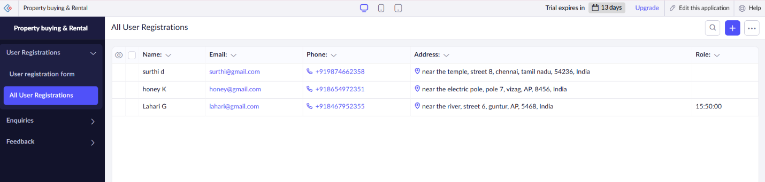

Form 2: Enquiry

Form 3: Feedback

Result: A cloud‑hosted SaaS web app where Chennai landlords list properties (sale/rent), users search by locality, submit applications, pay online, and manage contracts — all via subscription accounts.